**Test Case** **0022**

**System:** VirtuCardsClient & VirtuCardsHost

**Description:** Tests that the game handles each situation when a player leaves a game

**Severity:** 2

**Instructions**

**Test 1**

1. Start VirtuCardClient application
2. Click the button labeled “Sign In”
3. Enter “virtucards01@gmail.com” into the text input labeled “Enter email…”
4. Enter “Testing1” into the text input labeled “Enter password…”
5. Press the button labeled “Login”
6. A window should appear saying “Login Success”
7. Press the OK button that appears on that window
8. Start VirtuCardHost application
9. Repeat steps 2-7 but on the VirtuCardHost application
10. The checkbox “Allow Host to Join” should be checked on the host
11. Select from the drop down “Test Game”
12. Press the Create Game button
13. In the VirtuCardClient application enter the 6-character room code found on the host’s screen into the field labeled “Enter Code…”
14. Press the Join Game button on the client
15. The client should be taken to a waiting screen and the username “Testing0001” should appear on the host.
16. Press the Start Game button on the host.
17. Open the settings menu and click leave game

**Expected Result:** The host should return to the waiting screen shortly after the client exits the game.

**Test 2**

1. Start VirtuCardClient application
2. Click the button labeled “Sign In”
3. Enter “virtucards01@gmail.com” into the text input labeled “Enter email…”
4. Enter “Testing1” into the text input labeled “Enter password…”
5. Press the button labeled “Login”
6. A window should appear saying “Login Success”
7. Press the OK button that appears on that window
8. Start VirtuCardHost application
9. Repeat steps 2-7 but on the VirtuCardHost application
10. The checkbox “Allow Host to Join” should be checked on the host
11. Select from the drop down “Test Game”
12. Press the Create Game button
13. In the VirtuCardClient application enter the 6-character room code found on the host’s screen into the field labeled “Enter Code…”
14. Press the Join Game button on the client
15. The client should be taken to a waiting screen and the username “Testing0001” should appear on the host.
16. Press the Start Game button on the host.
17. Repeat the steps for the VirtuCard Client on a second device, signing in anonymously this time.
18. On the first device, open the settings menu and click leave game

**Expected Result:** A message should appear stating that “Testing001” has left the room.

**Test 3**

1. Start VirtuCardClient application
2. Click the button labeled “Sign In”
3. Enter “virtucards01@gmail.com” into the text input labeled “Enter email…”
4. Enter “Testing1” into the text input labeled “Enter password…”
5. Press the button labeled “Login”
6. A window should appear saying “Login Success”
7. Press the OK button that appears on that window
8. Start VirtuCardHost application
9. Repeat steps 2-7 but on the VirtuCardHost application
10. The checkbox “Allow Host to Join” should be checked on the host
11. Select from the drop down “Test Game”
12. Press the Create Game button
13. In the VirtuCardClient application enter the 6-character room code found on the host’s screen into the field labeled “Enter Code…”
14. Press the Join Game button on the client
15. The client should be taken to a waiting screen and the username “Testing0001” should appear on the host.
16. Press the Start Game button on the host.
17. Repeat the steps for the VirtuCard Client on a second device, signing in anonymously this time.
18. If the second device receives the turn first, skip their turn.
19. At the first devices turn, draw five cards, take note of their values, and leave the game by closing the app.
20. On the second device, draw 7 cards

**Expected Result:** A message should appear stating that “Testing001” has left the room. The second device should be able to draw 7 cards (the deck has 9 cards), since the players cards were readded to the unplayed deck. Out of the 7 cards draw, there should be atleast 3 of the cards present in the first device’s draw.

**Test 4**

1. Start VirtuCardClient application
2. Click the button labeled “Sign In”
3. Enter “virtucards01@gmail.com” into the text input labeled “Enter email…”
4. Enter “Testing1” into the text input labeled “Enter password…”
5. Press the button labeled “Login”
6. A window should appear saying “Login Success”
7. Press the OK button that appears on that window
8. Start VirtuCardHost application
9. Repeat steps 2-7 but on the VirtuCardHost application
10. The checkbox “Allow Host to Join” should be checked on the host
11. Select from the drop down “Test Game”
12. Press the Create Game button
13. In the VirtuCardClient application enter the 6-character room code found on the host’s screen into the field labeled “Enter Code…”
14. Press the Join Game button on the client
15. The client should be taken to a waiting screen and the username “Testing0001” should appear on the host.
16. Press the Start Game button on the host.
17. Repeat the steps for the VirtuCard Client on a second device, signing in anonymously this time.
18. On the first device, open the settings menu and click leave game
19. On the second device, open the settings menu and click leave game
20. Attempt rejoining the room and start a new game on both devices.

**Expected Result:** A message should appear stating that “Testing001” has left the room. The host should go to the waiting room after the second person. Joining the room again should result in no bugs, such as seeing names twice in the players list.

**Results:**

**Test 1**

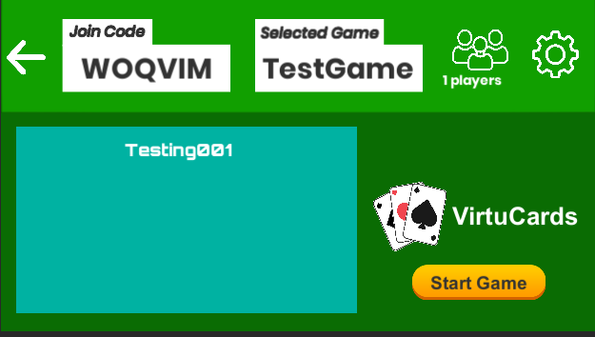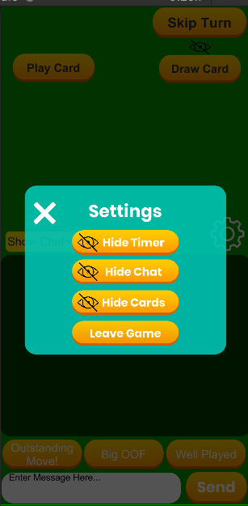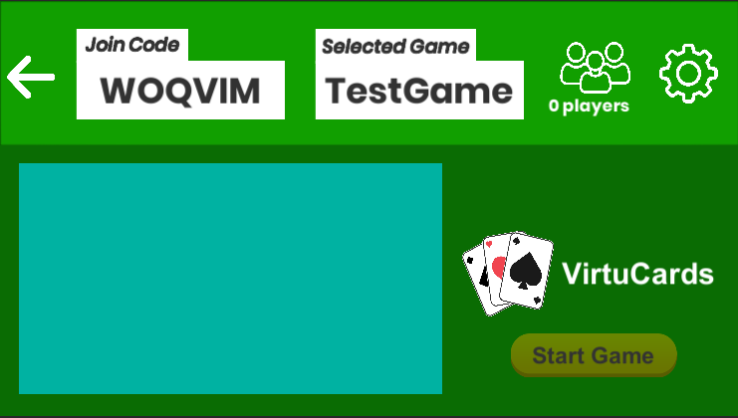 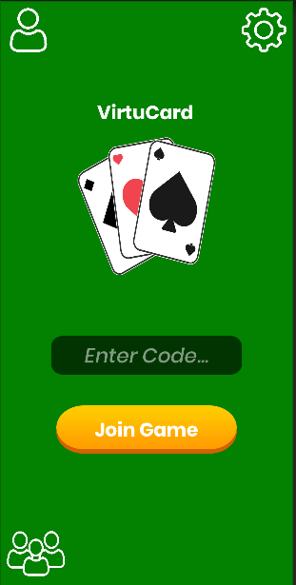

**Test 2**

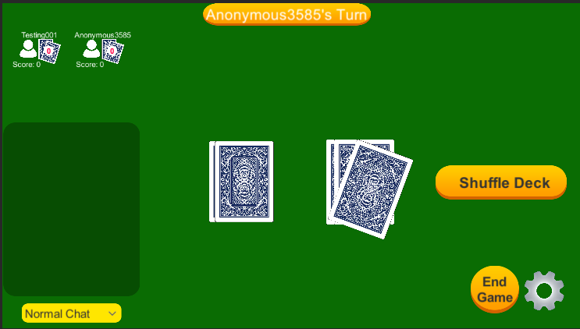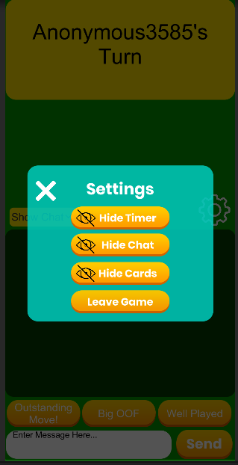

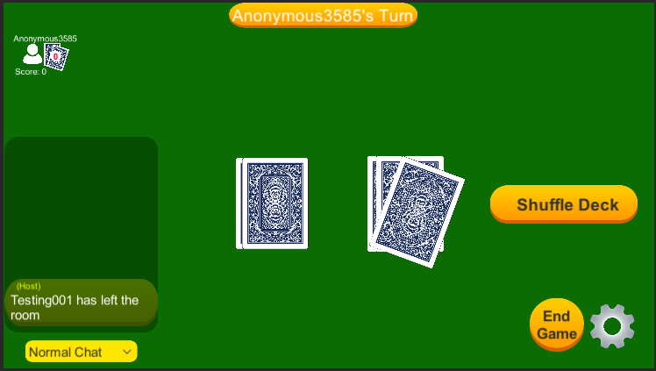

**Test 3**

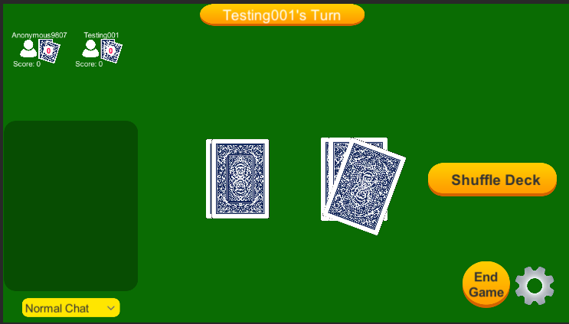

Player 1 Draws Five cards and leaves game

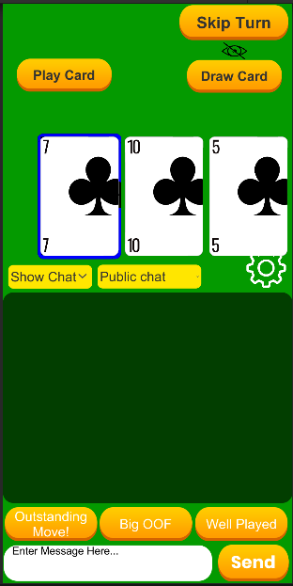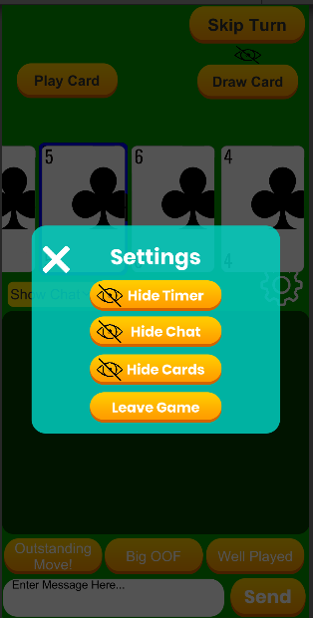

Chat message appears, player 2 draws seven cards

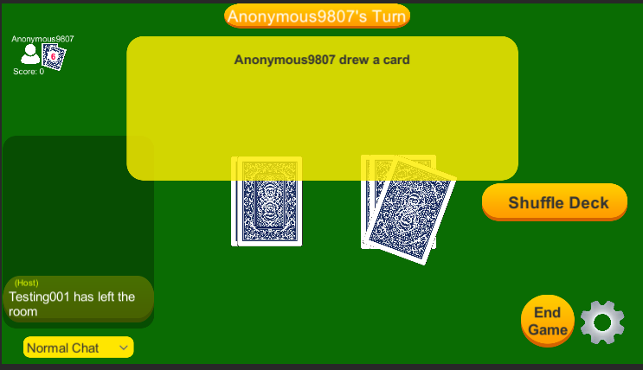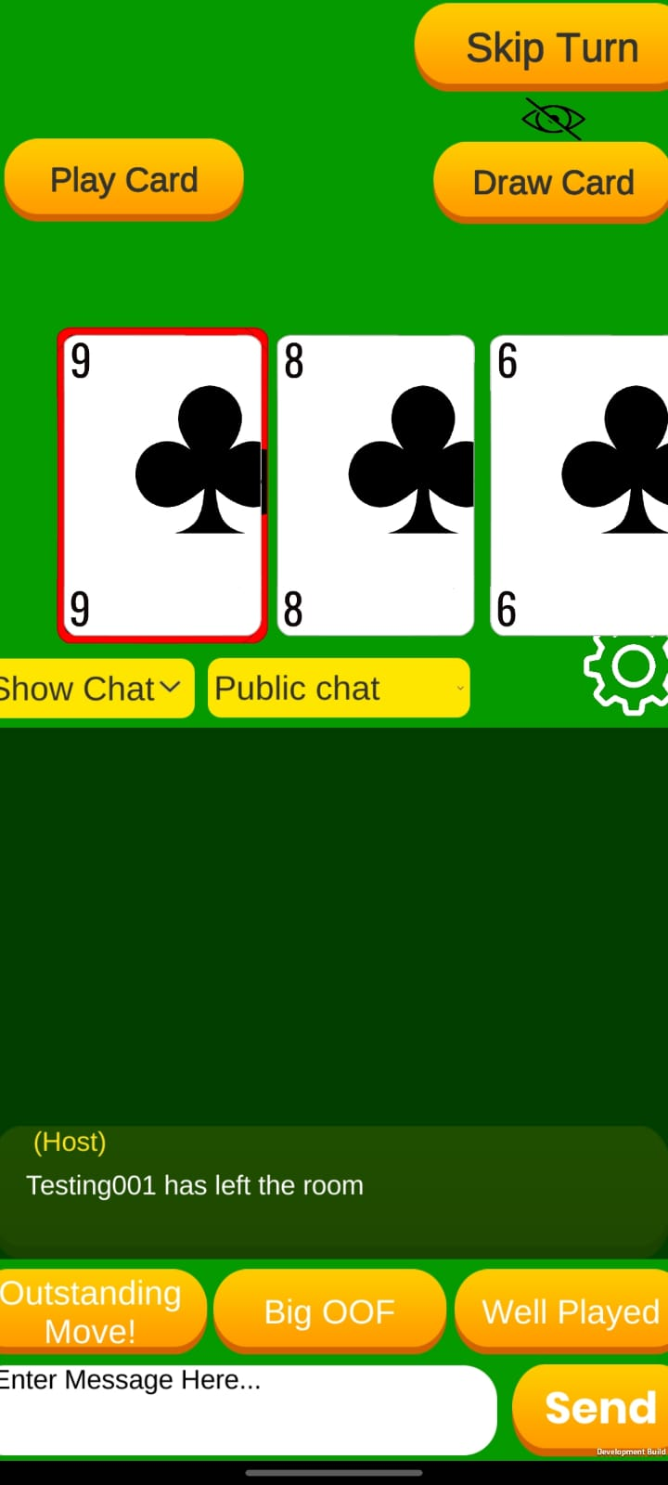 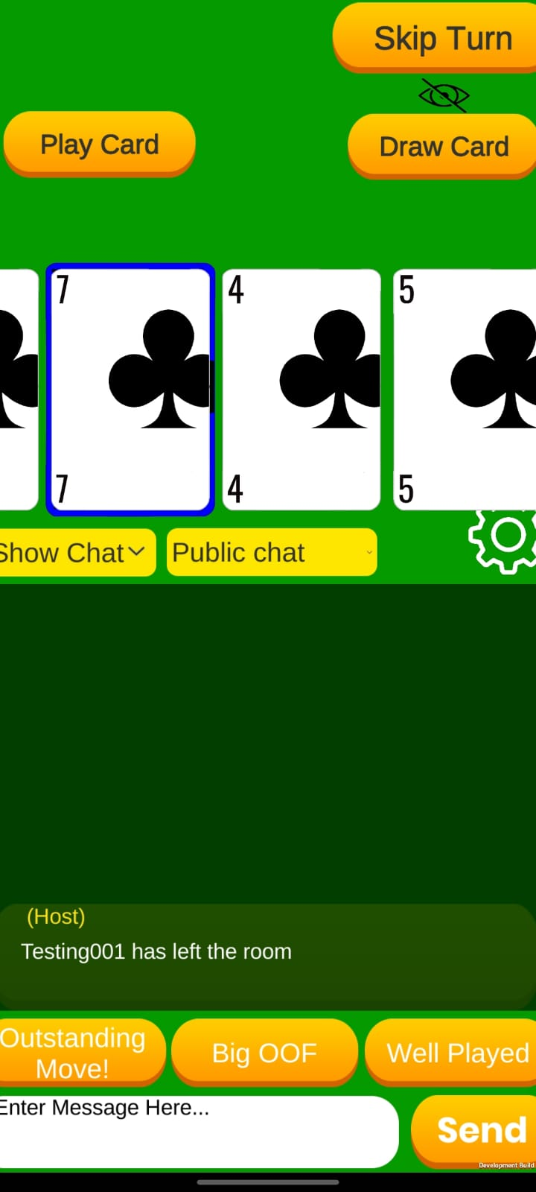 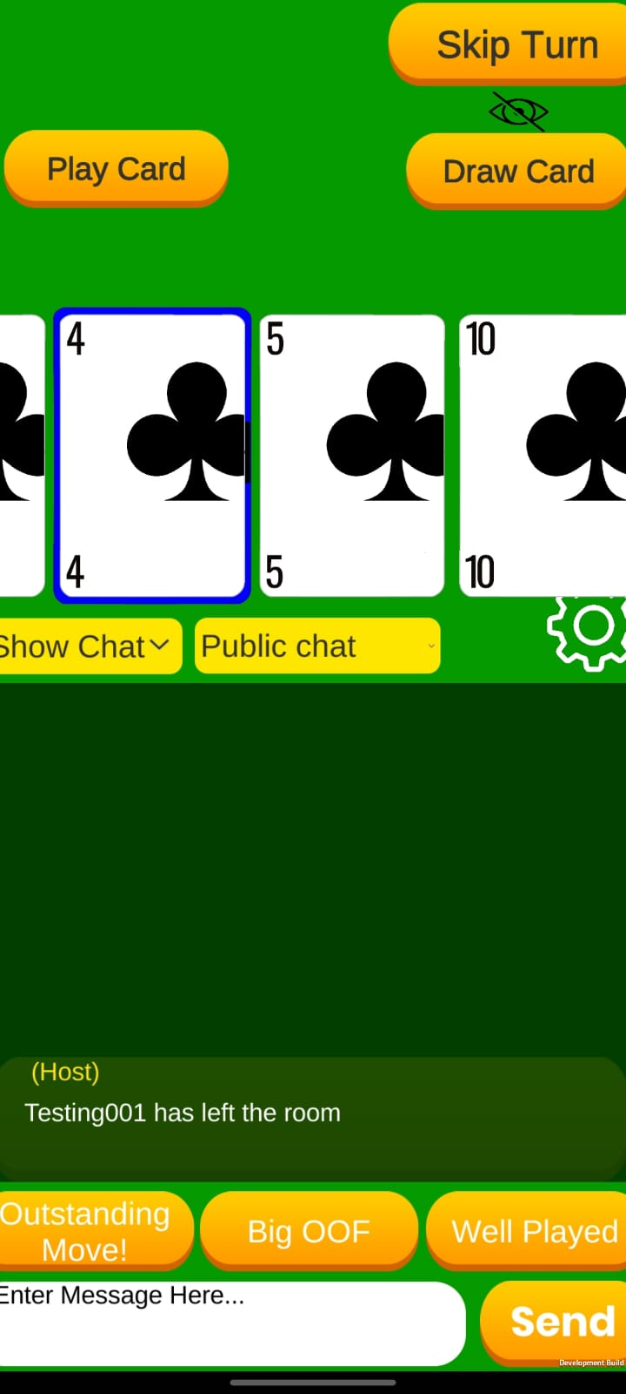

**Test 4**

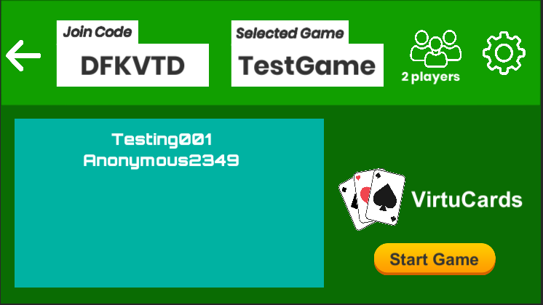

Leaving game.

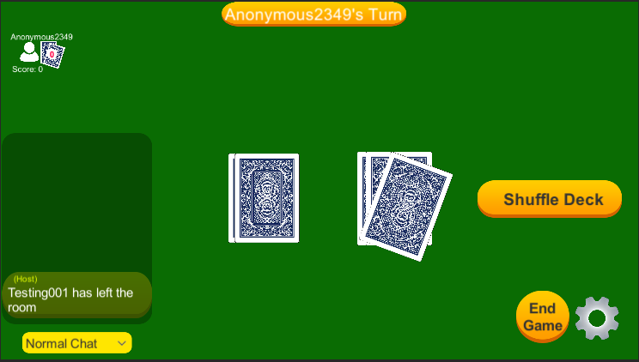

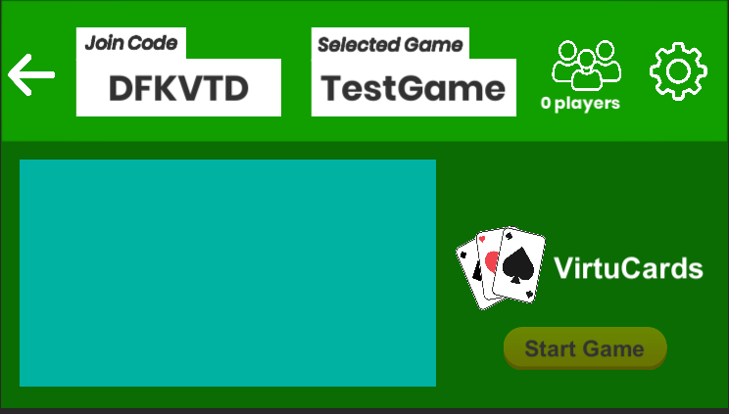

Rejoining Game

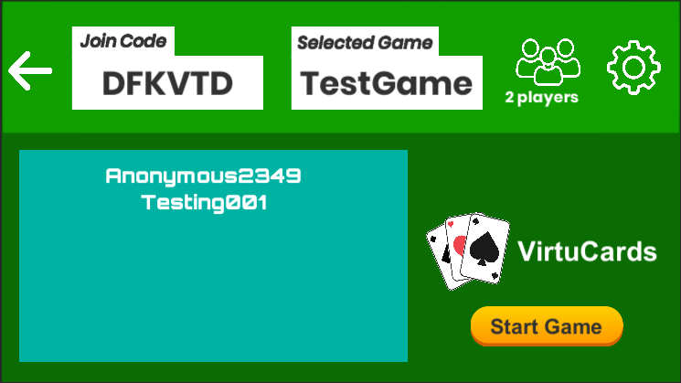

Game Proceeds as expected.

